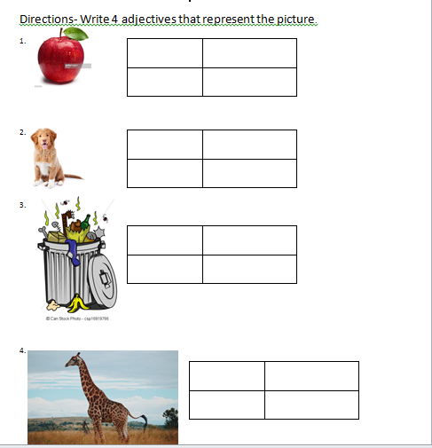
Assessment for engagement stage
Students had to look at the object and write four adjectives. The assessment helped the teacher know which student does not fully understand adjectives.
Assessment for the exploration phase
Students had to fill in the blank with an adjective that completes the sentence. The assessment helped the teacher know which students understand how to write adjectives.
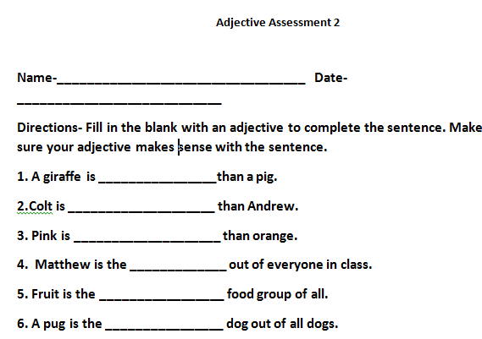

Partner and Group Worksheet for Exploration Phase
Students picked a partner and answered the question. Then they found another partner and answer another question. For numbers 5-7 students worked in groups and answered the questions. The worksheet helped the students explore ways to write comparative and superlative adjectives.
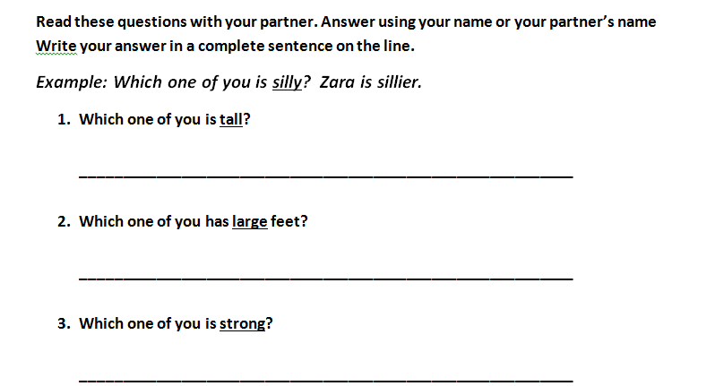

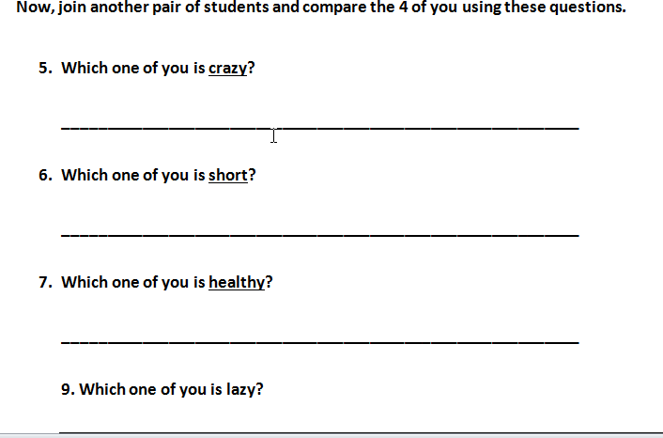

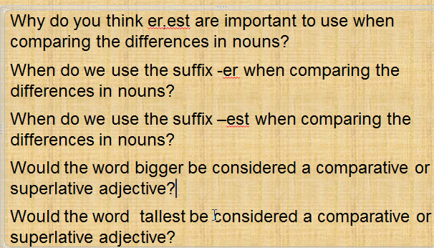
Assessment for Explanation Phase
Students had to answer each question on their personal white boards. The questions would show one at a time. The assessment helped the teacher know which student understands the differences and properties of comparative and superlative adjectives.

